Description

The project is about a Todo application where one can add a todo with a title description and the date the task to be completed.
The application has an edit part where the data can be updated through the input props
The project has two parts where the Front-end is the view user can interact with which is built using Angular.
The Front end has three main parts,the Form to store to enter the Todo, the place to view the done and another part for the undone todo.
The front end communicates with the Back end to create,update,delete and update a todo.
The Endpoint is the part which handles the processing of the data.
It stores and does operations to the data and then stores them on the database,mongo database,
The endpoint has a folder for Routs which store 5 Routs ie
- Getting the Todos
- Updating Todo
- Creating Todo
- Getting a Todo
- Deleting a Todo

The project is working as expected.

The Following are Screenshots of the user interface

When Empty
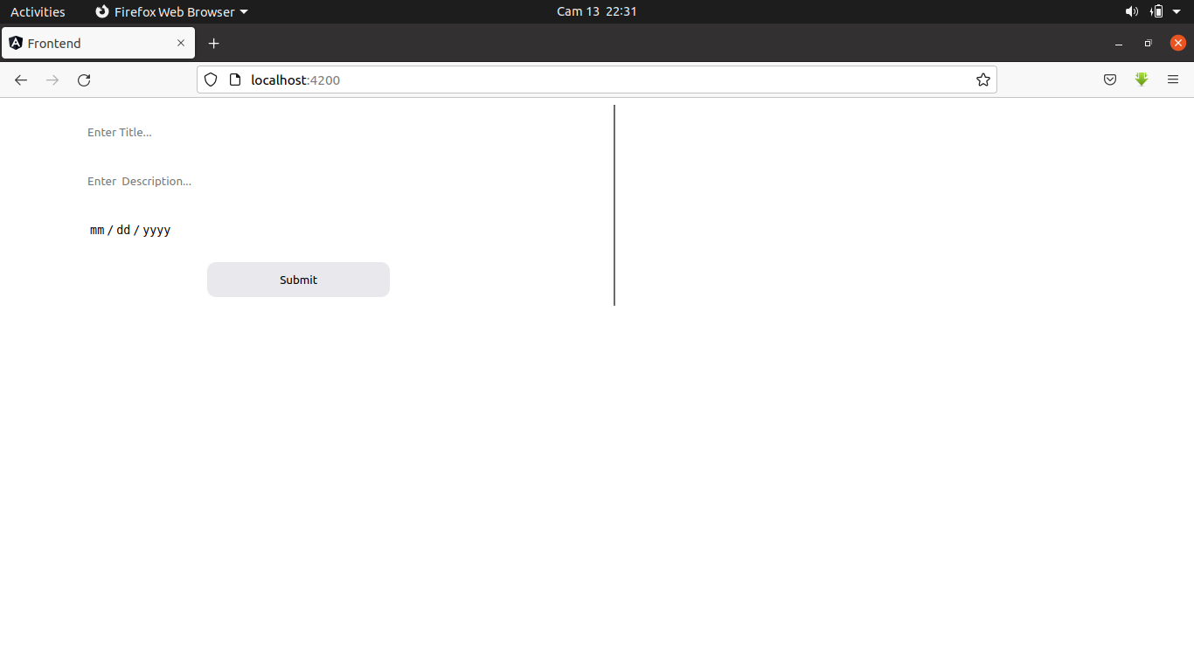

WITH SOME TODOS

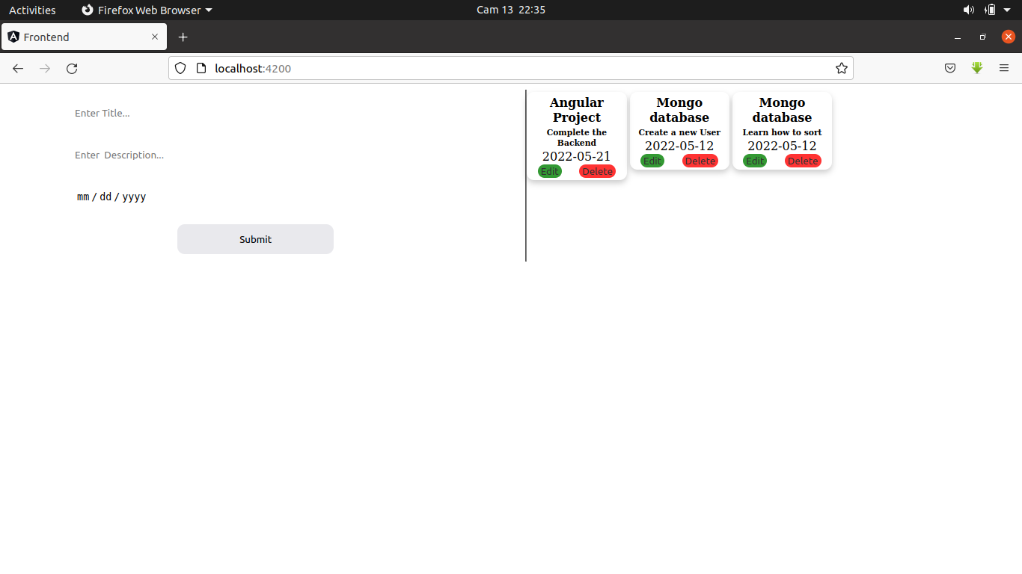
UPDATING A TODO

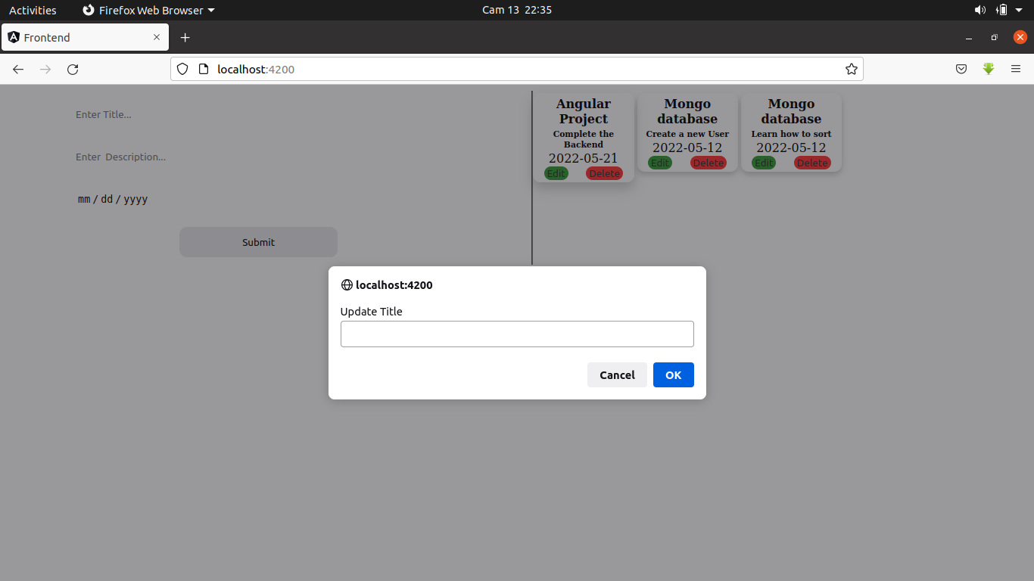

UPDATED DATA WITH A COMPLETE TODO

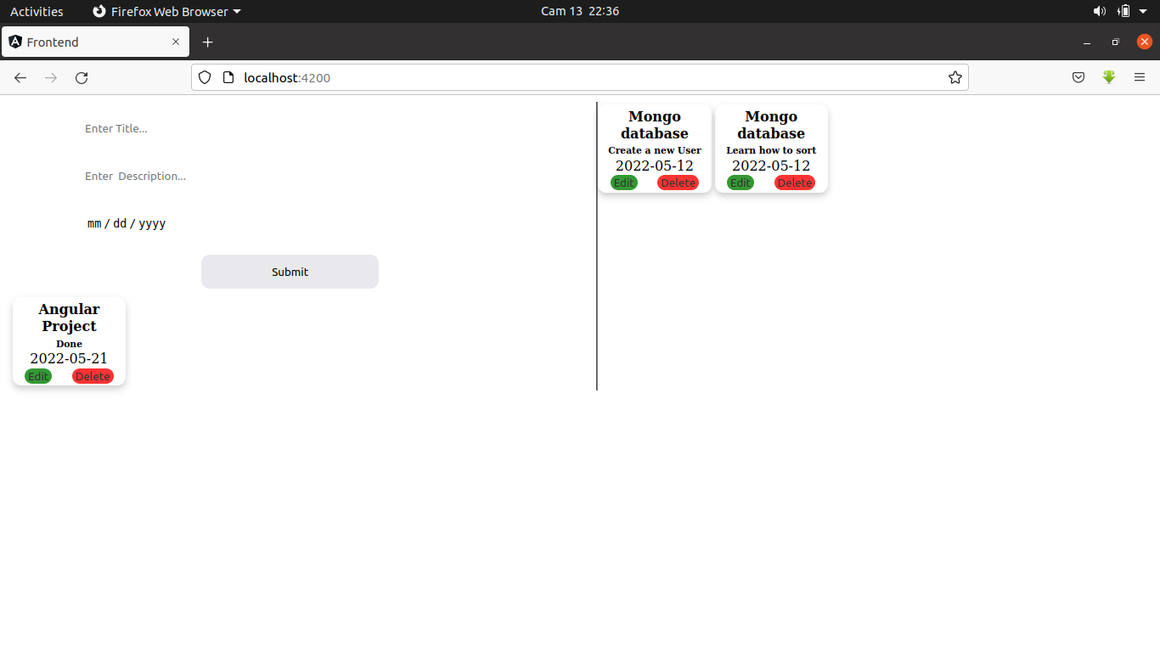

Challenges

I had a main challenge while working on the challenge was using component to handle state from children to the parent component then back to other children.
I tried many methods without success so I need to research more on that to understand component again
another challenge was updating the dom automatically when state changes which I haven’t done

